SOFTWARE DESIGN

DOCUMENT



H.O.B.B.I.T

*‘OUTGROW YOUR INTEREST* ’

TEAM MEMBERS

1. ANJALI MISHRA(BT17GCS154)-C2
2. ARUSHI SEHGAL (BT17GCS017)-C1
3. ARUNDHATI DAS(BT17GCS016)-C2
4. AYUSHI KAPOOR (BT17GCS020)-C2
5. TANISHA GARG(BT17GCS113)-C1
6. BHAVYA MASUPALLI (BT17GCS271)-c1
7. HIMANSHU NIKHARE (BT17GCS036)-C4

**TABLE OF CONTENTS**

**1 INTRODUCTION**

1.1 Purpose

1.2 Scope

1.3 Intended audience

1.4 Definitions, Acronyms and Abbreviations

1.5 advantages

1.6 references

**2 USE CASES**

2.1 Actors

2.2 List of Use Cases

2.3 Use Case Diagram

**3. SYSTEM ARCHITECTURE**

3.1 Architectural Design

3.2 Decomposition Description

**4. DATA DESIGN**

4.1 Data Description

4.2 Entity Relationship Diagram

4.3 Class Diagram

**5. COMPONENT DESIGN**

5.1 Component Model

**6. HUMAN INTERFACE DESIGN**

6.1 Overview of User Interface

6.2 User Interface Flowchart

6.3 Screen Images and Actions

**1. INTRODUCTION**

This document is prepared in order to determine a Software Design Document for the app H.O.B.B.I.T . Within the Software Design Document are narrative and graphical documentation of the software design for the app including use case models, sequence diagrams, ER diagrams, and other supporting requirement information.

**1.1 PURPOSE**

The purpose of the Software Design Document is to provide a description of the design of a system fully enough to allow for software development to proceed with an understanding of

What is to be built and how it is expected to built. The Software Design Document provides information necessary to provide description of the details for the software and system to be built.

**1.2 SCOPE**

This Software Design Document is for a base level system which will work as a proof of concept for the use of building a system that provides a base level of functionality to show feasibility for large scale production use. The name of the software product is H.O.B.B.I.T. which is a social networking app that connects people via a digital platform.

**1.3 INTENDED AUDIENCE**

This document is meant for a varied set of audiences. This document serves as a contract agreement with developer. The document is intended for the software developer authorities, the design team, developers, project manager, team leads, supervisors, security analysts, testing team and the QA team to better understand the system necessities , knowledge and understanding of UML diagrams is also needed.

**1.4 DEFINITIONS, ACRONYMS AND ABBREVIATIONS**

When the user logins into the app, they’ll see their home page, which is called as “News Feed” that offers users to envision what their friends have shared in the form of stories and posts. Moreover, the user will see the event invites and calendar updates. Therefore, News Feed is that main page which combines daily friend interactions.

**1.5 ADVANTAGES**

The advantages of this app is to bring people of similar interests closer . Usually , users of a particular geographical location may be interested in similar activities and hobbies but are unable to connect due to various factors . Therefore, to make the people of varied interests come closer, this app helps to join in and make the world a happier and closer place . Moreover, this kind of app helps people who have recently located to find and make new friends.

**1.6 REFERENCES**

IEEE SDD Format.

**2.USE CASES**

* **2.1**  Actors
  + Super Admin
  + Group Admin
  + Users
* **2.2**   List of Use Cases  
  + Manage Users and Full Application
  + Manage Users
  + Manage Social Network
  + Login and Logout from system
  + Update my profile
  + Change account password
  + Signup
  + Manage Post
  + Manage Events
  + Manage Interest
  + Search Events
  + Send Message Request
  + Upload Posts
  + Responding to Events/Interest
  + View Information
  + Fill Info
  + Search Content

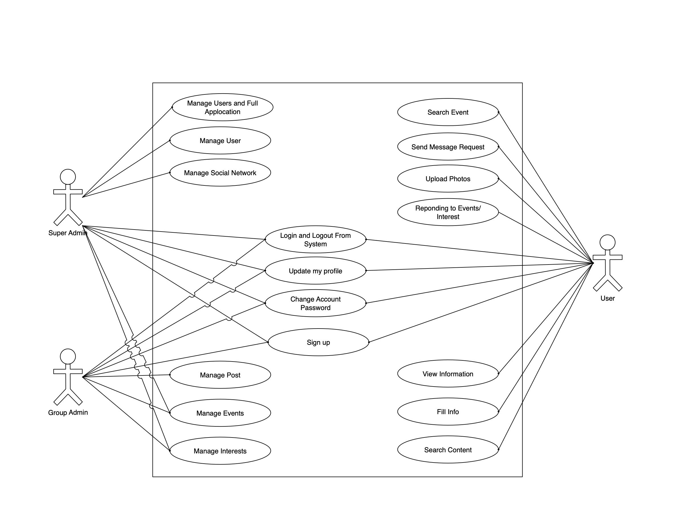

**Figure:** Use Case diagram for H.O.B.B.I.T App

**3. SYSTEM ARCHITECTURE**

**3.1 ARCHITECTURAL DESIGN**

The Activity UML diagram of Hobbit App which shows the flows between the activity of Videos, Users, Interest Groups, Photos, Posts. The main activity involved in this UML Activity Diagram of Hobbit App are as follows:

* Videos Activity
* Users Activity
* Interest Group Activity
* Photos Activity
* Posts Activity

**Features of the Activity UML Diagram of HOBBIT**

Admin user can search videos, view description of selected videos, add videos, update videos, delete Videos, and join Group, Create Group.

• Its shows the activity flow of editing, adding and updating of users. User will be able to search and generate report of interest groups, photos, posts All objects such as ( Videos, Users, Posts) are interlinked.

• Its shows the full description of videos, photos, posts, interest groups, users.

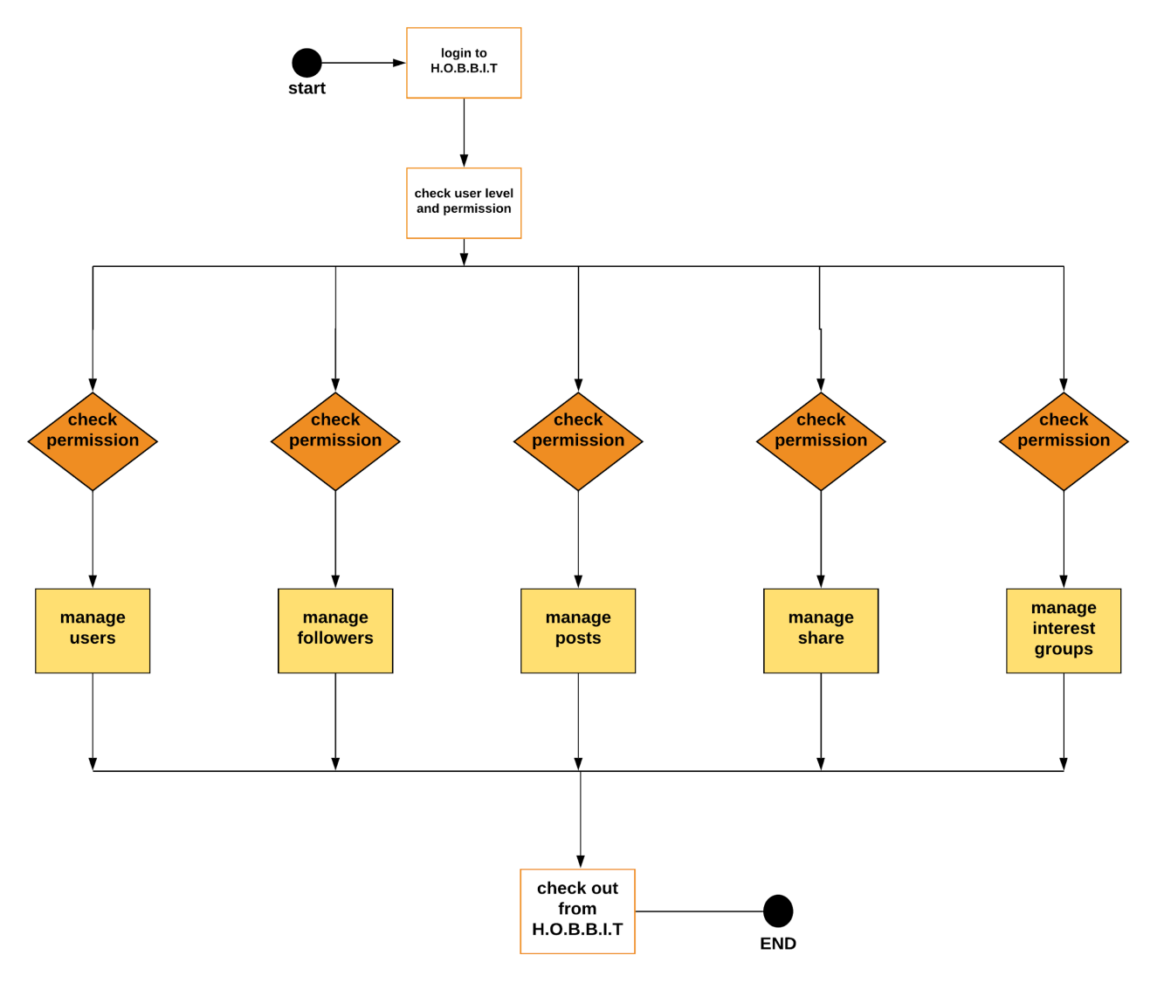

**Login Activity Diagram Of Social Networking Site:**

This is the Login Activity Diagram of Hobbit App, which shows the flows of Login Activity, where admin will be able to login using their username and password. After login user can manage all the operations such as Interest Groups, Videos, Users, Posts, and Photos. All the pages such as Users, Posts, Photos, Interest Groups are secure and user can access these page after login. The diagram below helps demonstrate now the login page works in a Hobbit App. The various objects in the Posts, Interest Groups, Videos, users, and Photos page—interact over the course of the Activity, and user will not be able to access this page without verifying their identity.

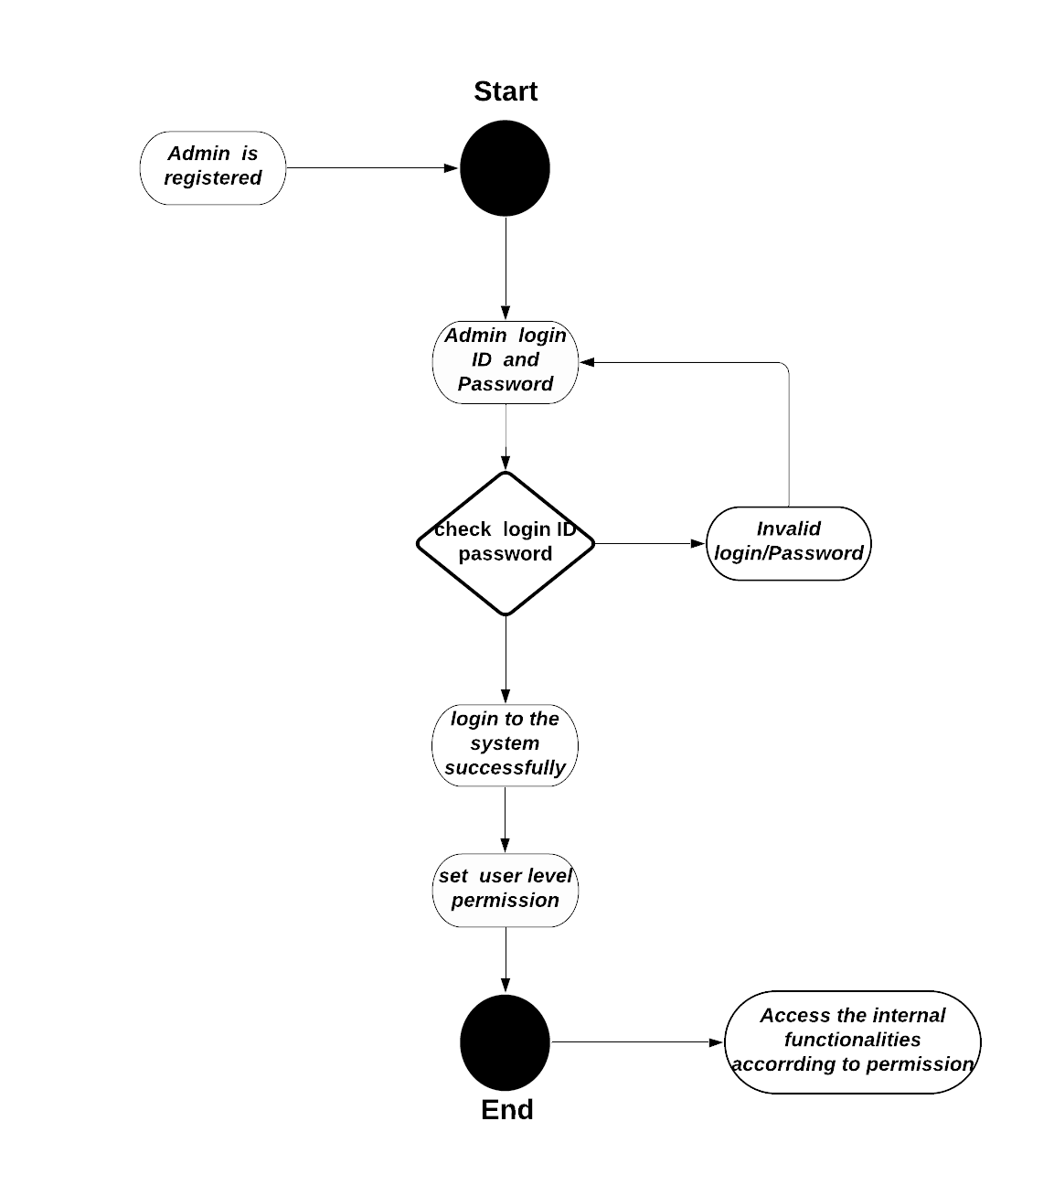

**3.2 DECOMPOSITION DESCRIPTION**

**Login Sequence Diagram**

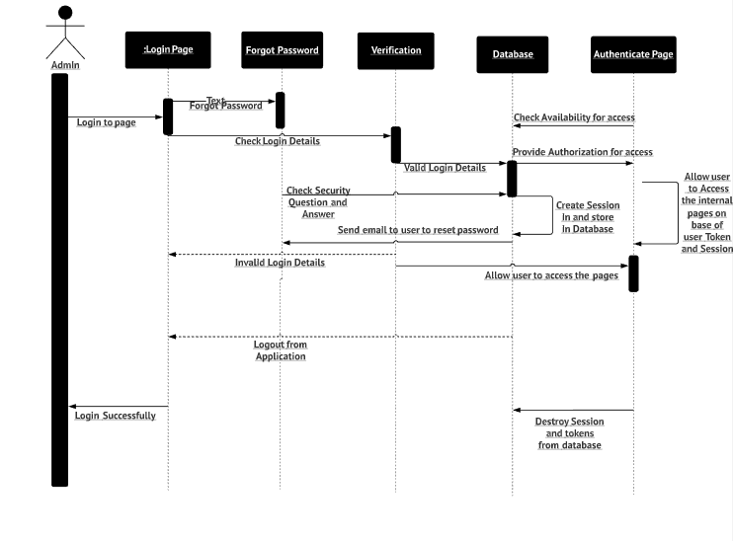

This is the Login Sequence Diagram of Hobbit App, where admin will be able to login in their account using their credentials. After login user can manage all the operations on Friends, Videos, Interest Groups, Photos, Posts. All the pages such as Interest Groups, Photos, Posts are secure and user can access these page after login. The diagram below helps demonstrate now the login page works in a Hobbit App. The various objects in the Photos, Friends, Videos, Social Network, and Posts page—interact over the course of the sequence, and user will not be able to access this page without verifying their identity.

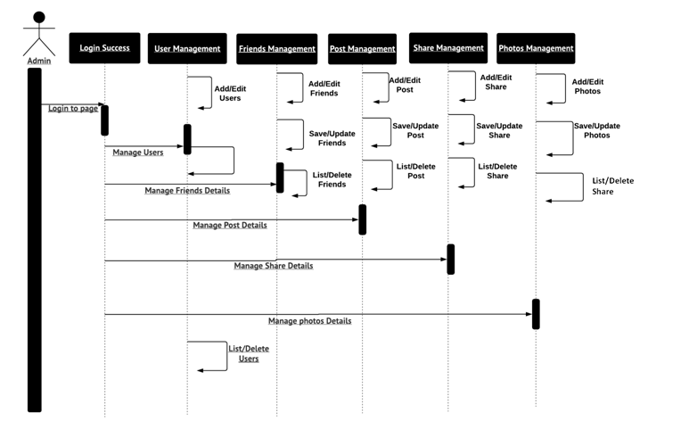

**Zero Level Dataflow Diagram**

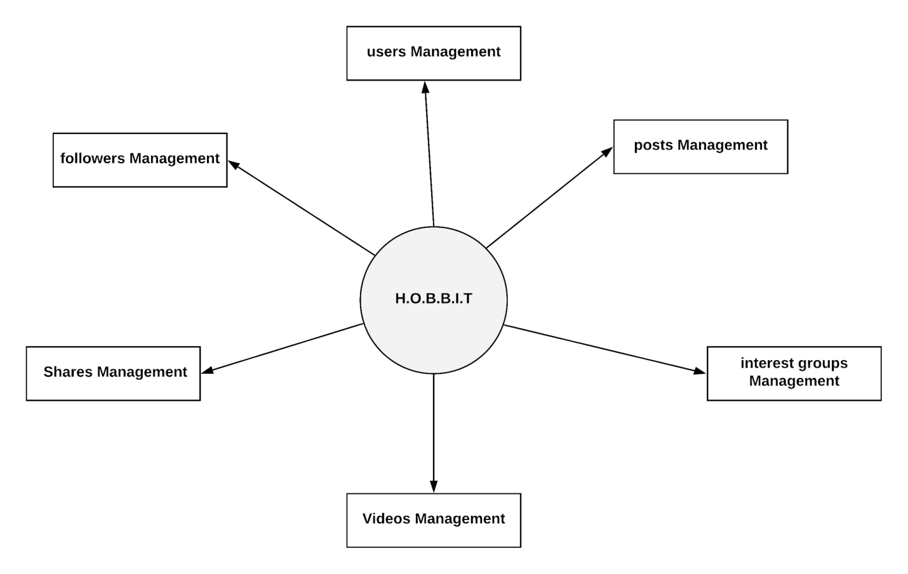

**First Level Dataflow Diagram**

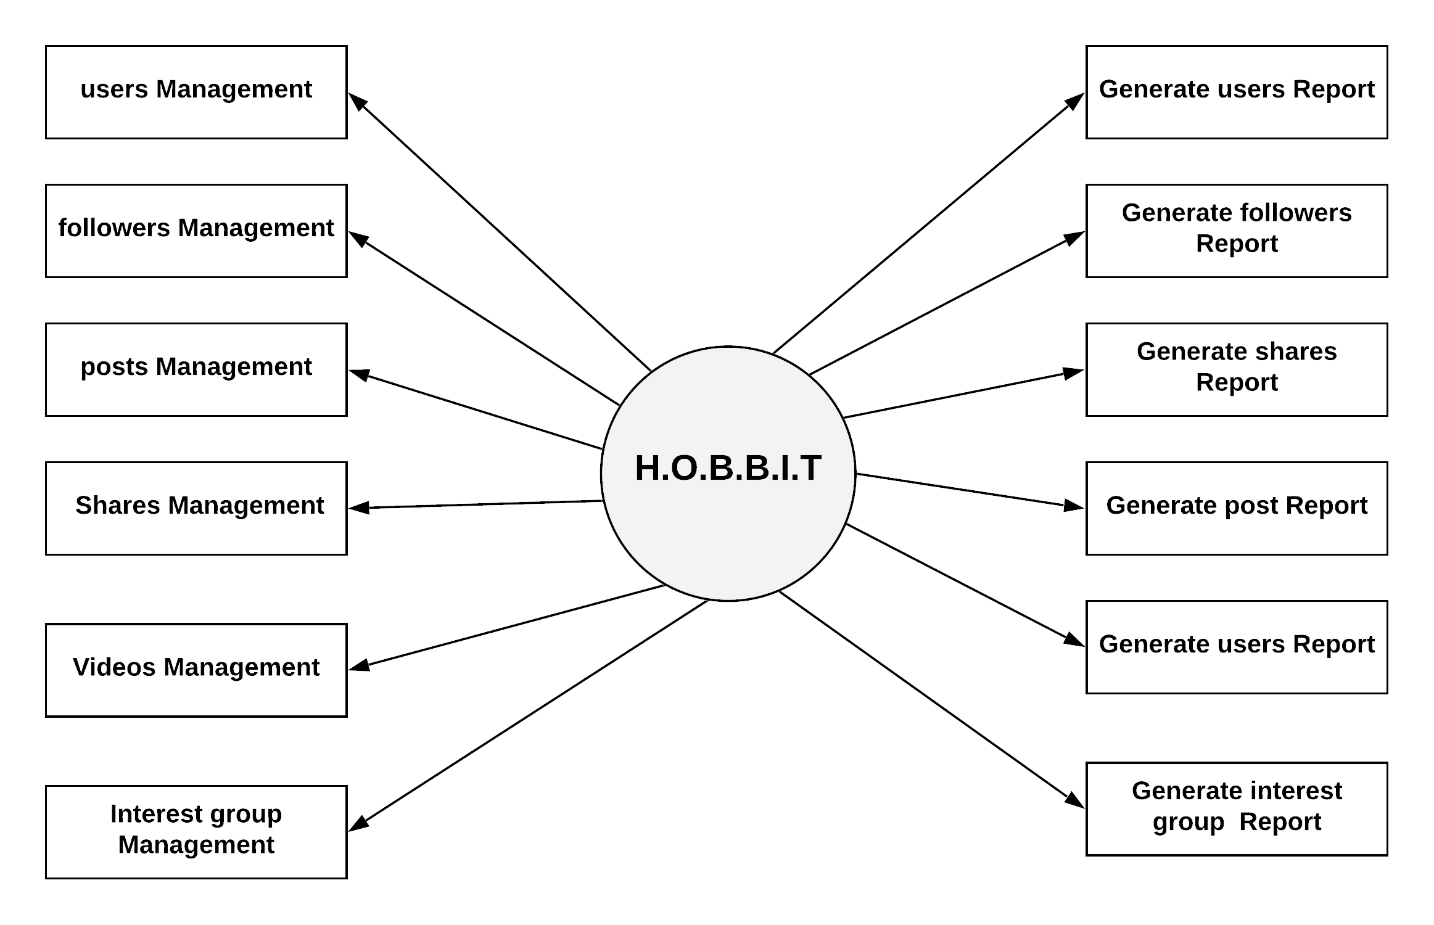

**Second Level Dataflow Diagram**

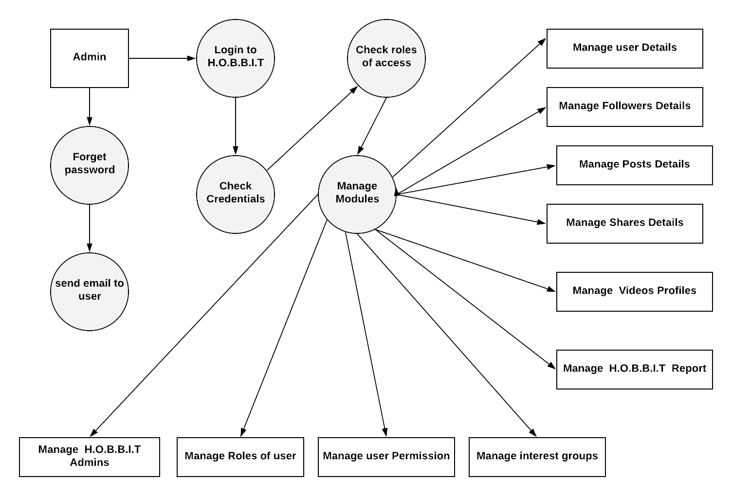

**4. DATA DESIGN**

4.1 Data Description

**Entities:**

Permission

Login

Groups

User

Follower

Post

Events

Photos

Shares

**Attributes:**

Per_id

Per_name

per_role_id

per_module

login_user name

user_password

user_name

user_id

user_mobile

user_email

user_address

group_name

group_members

group_description

follower_name

follower_id

follower_mobile

follower_add

follower_email

photo_size

photo_id

photo_type

photo_name

events_name

upcoming_events

event_start

event_end

post_desk

post_type

post_id

like

share

comment

share_post_id

**4.2 ENTITY RELATIONSHIP DIAGRAM**

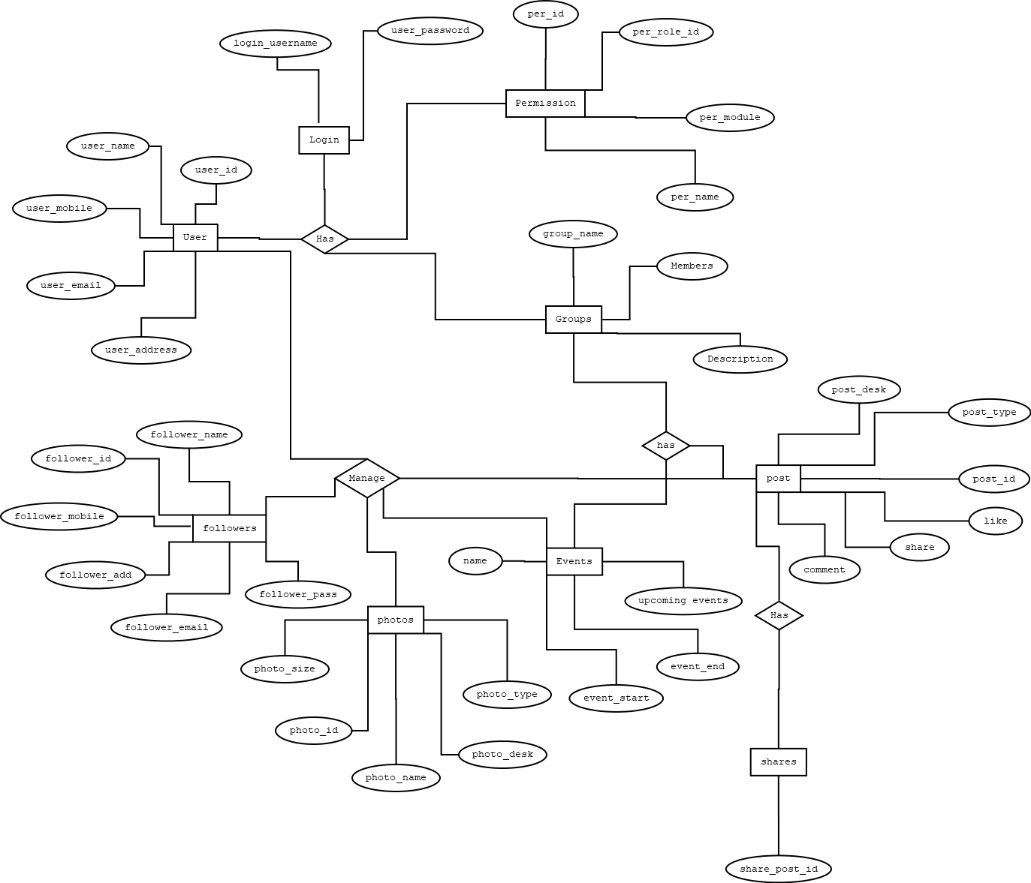

**Figure:** ERDiagram for H.O.B.B.I.T App

**4.3 Class Diagram**

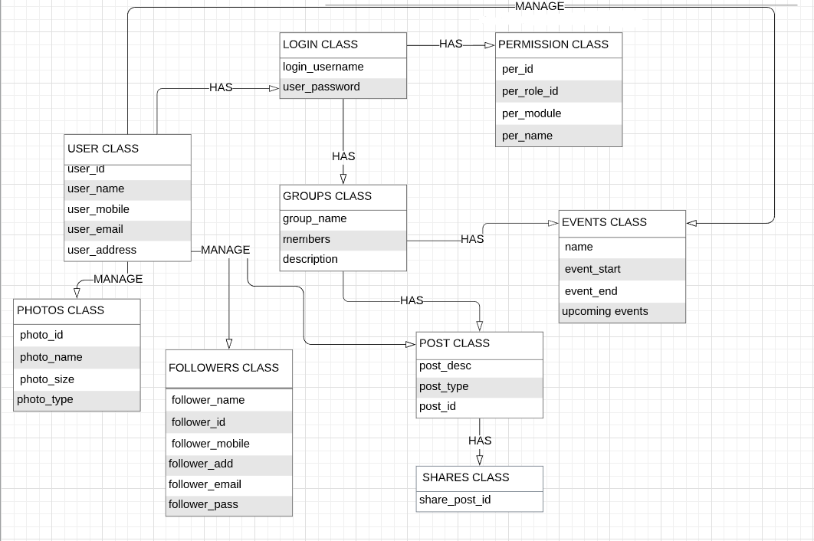

**Figure:** ClassDiagram for H.O.B.B.I.T App

**5. COMPONENT DESIGN**

**5.1 COMPONENT MODEL**

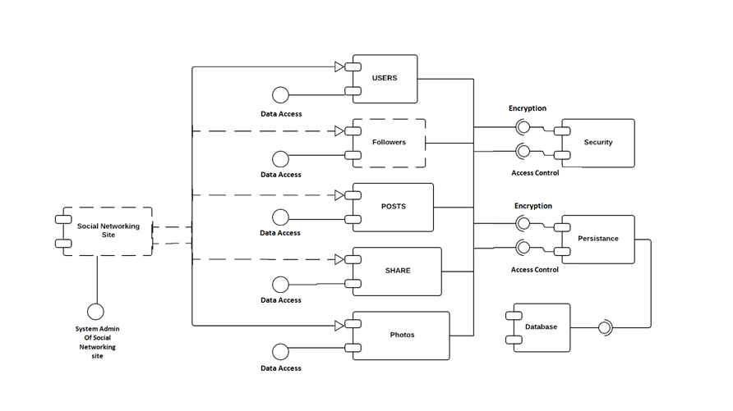

**app**

**Hobbit**

**6. HUMAN INTERFACE DESIGN**

**6.1 OVERVIEW OF USER INTERFACE**

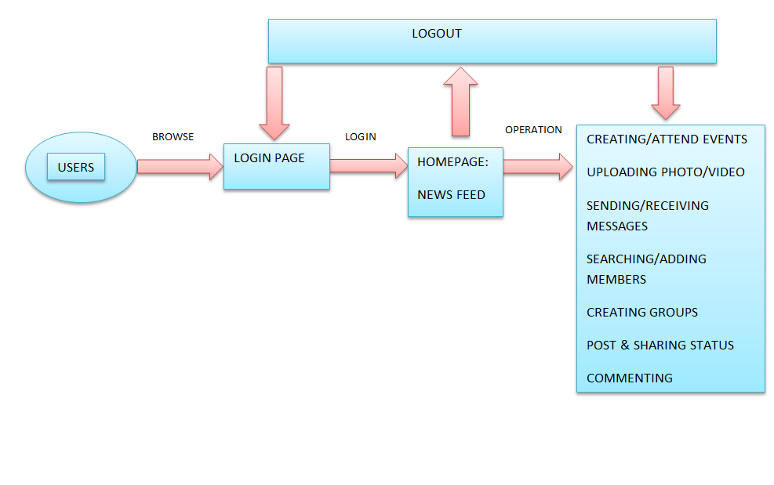

**Figure:** Diagram for Standard User Interface For H.O.B.B.I.T App

**Hardware Interface**

A smart phone with internet connection ability is the hardware interface of this system. Internet connection of smart phone is also required. A working based smart phone with version 2.2 or above and internet connection are necessary.

**Software Interface**

The system is on server so it requires any scripting language like PHP, VBScript etc. The system requires database also for the store any transaction of the system like MYSQL etc. system also require DNS (domain name space) for the naming on the internet. At the last user need web browser for interact with the system.

**Communication Interfaces**

The network communication is always necessary for the application to run. Since all the information, i.e. user information, album information, messages, etc. of the system is kept in a server and all the processing is done on the server side hence network communication is vital for Hobbit app.

**6.2 USER INTERFACE FLOW DIAGRAM**

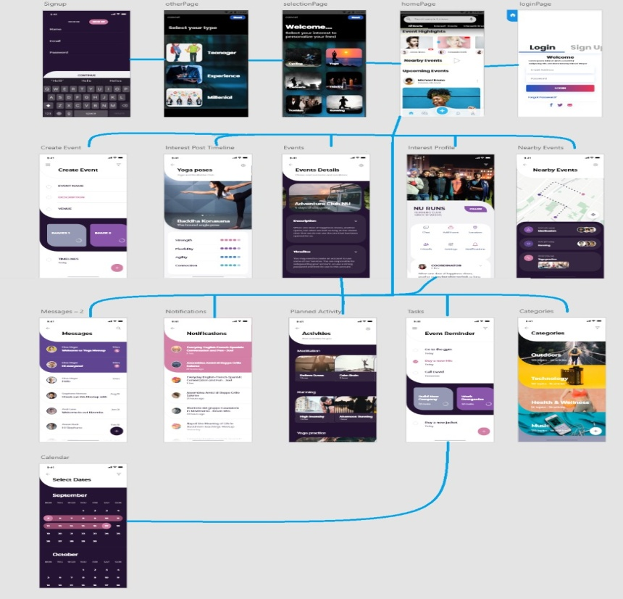

**6.3 SCREEN IMAGES AND ACTIONS**

**Create Account:**

If user is new and does not have an account on H.O.B.B.I.T.

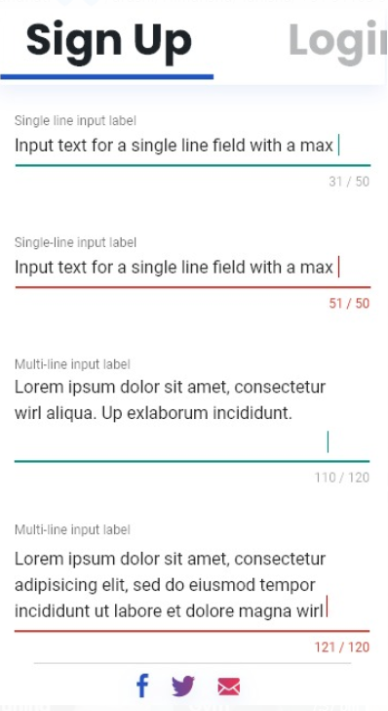

**Sign in Account:**

If user already have an account on H.O.B.B.I.T.

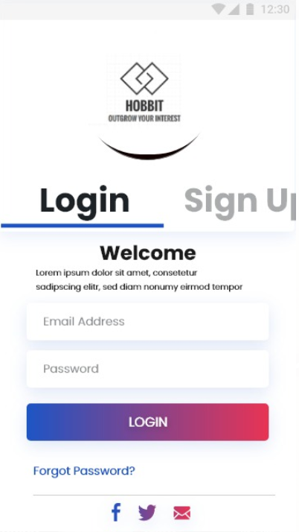

**Choosing Groups:**

User chooses the Interest Group.

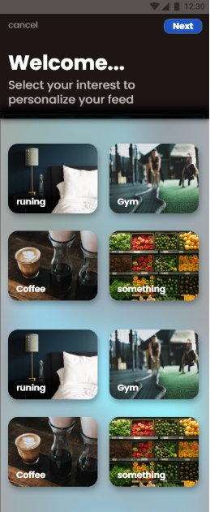

**Searching Groups:**

User searches for Interest Group to join.

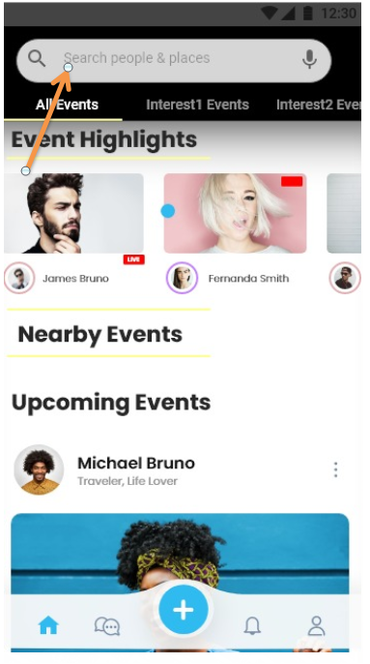

**Uploading Photos:**

Users can add photos on Hobbit to update their activities

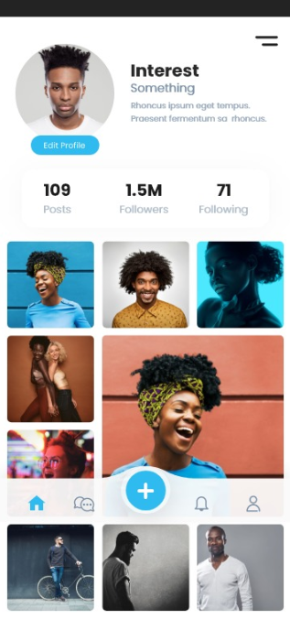

**Commenting:**

This feature will allow individuals to comment on shared status on hobbit. This would be done by an interface of text field located at the bottom of every status.

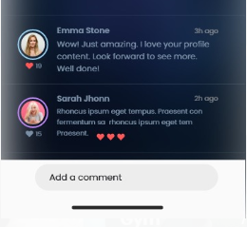

**Planner**

Ithelps in looking up the dates of the upcoming events and to plan and schedule about them well in advance.

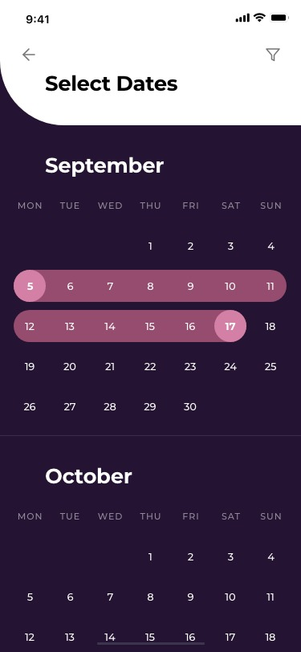

**Nearby Event**

To see the nearby events happening nearby to the location of the individual using the app.

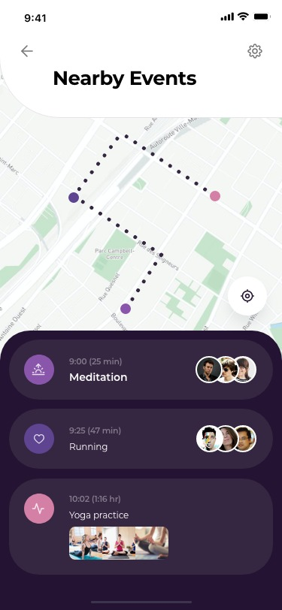

**Event Reminders:**

To set the reminders for the upcoming events.

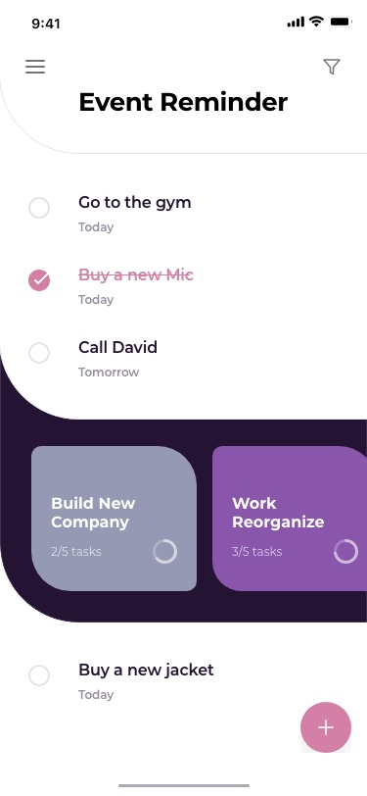

**Sending Message**

A user should be able to send instant messages to the members of the interest group. User should be notified when messages are successfully delivered to recipient by displaying a tick sign next to message sent.

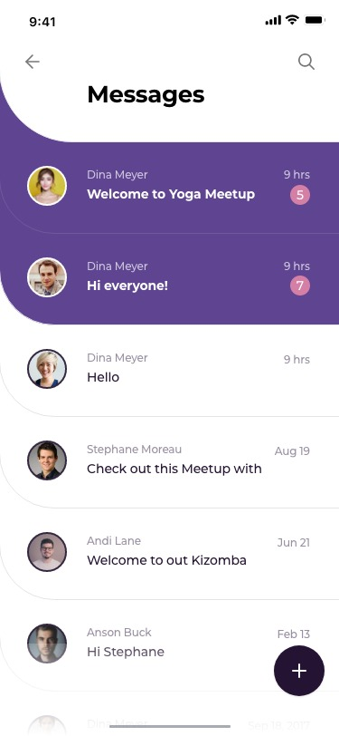

**Creating an Event:**

User can create an Event through his Page to connect to his audience.

